GE2P_c54x.mem

MEMORY c54x
(FAMILY = c54x)
{
SPACE program_memory PAGE 0 :
EPROG (RWXI): o= 0x8000 e= 0xFFFF

SPACE data_memory PAGE 1 :
CPUREGS (RWI ): o= 0x0000 e= 0x005E
USERREGS(RWI ): o= 0x0060 e= 0x007B
BIOSREGS(RWI ): o= 0x007C e= 0x007F
IDATA (RWI ): o= 0x0080 e= 0x7FFF
EDATA (RWI ): o= 0x8000 e= 0xFFFF

SPACE IO_memory PAGE 2 :
}

/* Table of address ranges vs. sets of spaces that share them. */
/* For each entry in the table, */
/* if a region's parent appears in the space set */
/* and the region is fully contained in the address range, */
/* then the region is shared with the other spaces of the set. */

SHARED_ADDRESSES c54x
{
o= 0x80 e= 0x7FFF { program_memory, data_memory }
}

GE2P.cmd

MEMORY
{
PAGE 0: EPROG: origin = 0x8000, len = 0x8000

PAGE 1: CPUREGS: origin = 0x0, len = 0x005F
USERREGS: origin = 0x60, len = 0x001c
BIOSREGS: origin = 0x7c, len = 0x0004
IDATA: origin = 0x80, len = 0x7F80
EDATA: origin = 0x8000, len = 0x8000
}

SECTIONS
{
.vectors: {} > EPROG PAGE 0 // fill 00000000
.text: {} > EPROG PAGE 0 // fill 00000000

.sysregs: {} > BIOSREGS PAGE 1 // no fill

.b1mem: {} > IDATA PAGE 1 // no fill
.sysparm: {} > IDATA PAGE 1 // fill 00000000
.msgbuf: {} > IDATA PAGE 1 // no fill
.bss: {} > IDATA PAGE 1 // no fill
.MEM$obj: {} > IDATA PAGE 1 // no fill
.cio: {} > IDATA PAGE 1 // no fill
.far: {} > IDATA PAGE 1 // no fill
.sysheap: {} > IDATA PAGE 1 // no fill
// .sysmem: {} > IDATA PAGE 1
.stack: {} > IDATA PAGE 1 // no fill
.pinit: {} > IDATA PAGE 1 // fill 00000000
.cinit: {} > IDATA PAGE 1 // fill 00000000
.switch: {} > IDATA PAGE 1 // fill 00000000
.sysinit: {} > IDATA PAGE 1 // no fill
.const: {} > IDATA PAGE 1 // fill 00000000
.data: {} > IDATA PAGE 1 // fill 00000000
.d2_rev: {} > IDATA PAGE 1, type=DSECT // fill 00000000
.vsb_rev: {} > IDATA PAGE 1, type=DSECT // fill 00000000
}

Memory Maps / c54x

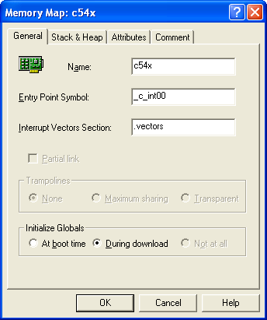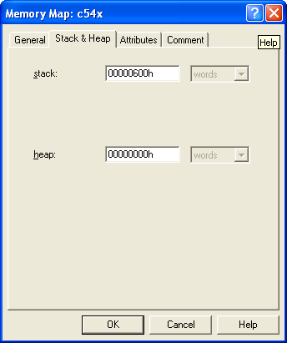

run_view / program_memory

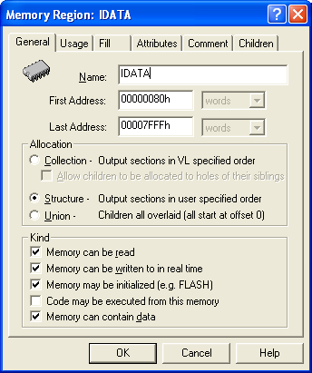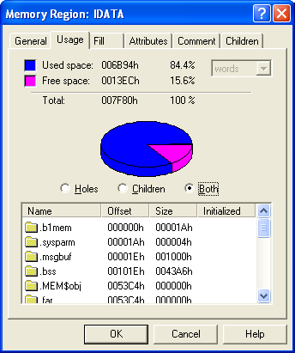
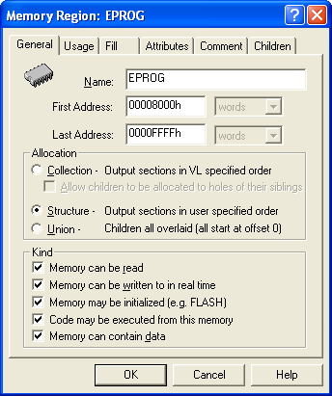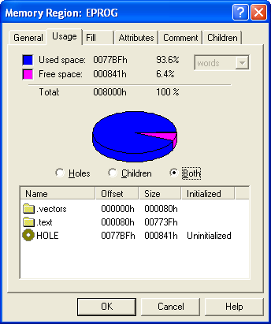

run_view / data_memory

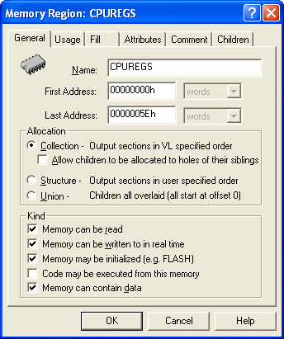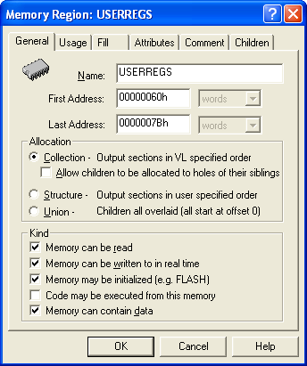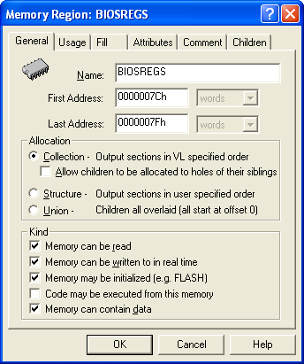
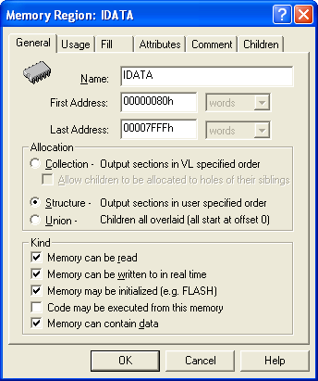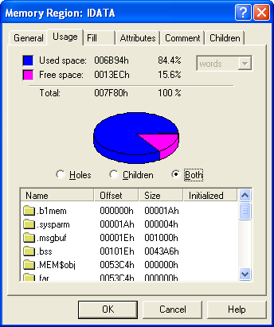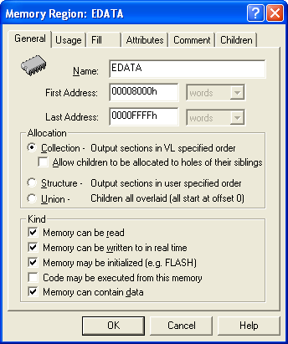

load_view / program_memory

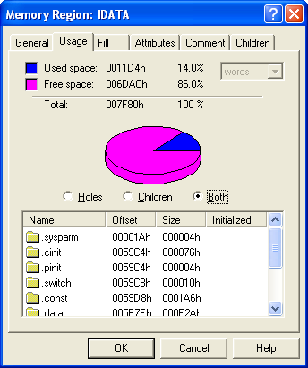
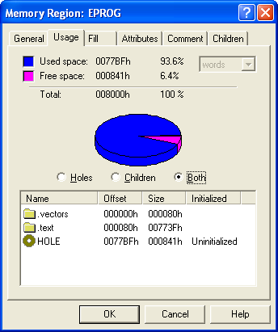

load_view / data_memory

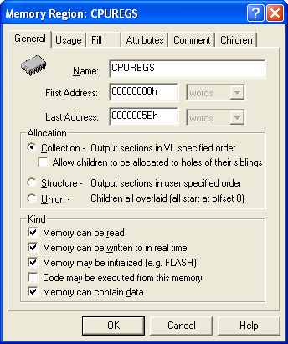

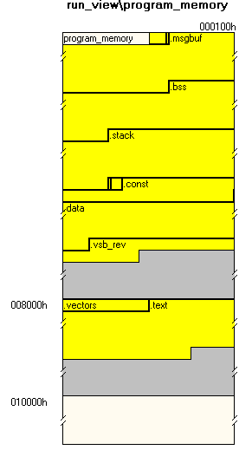 | 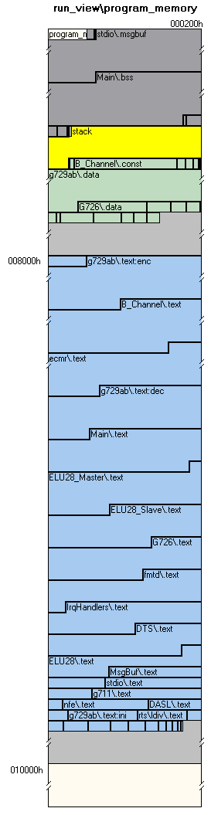  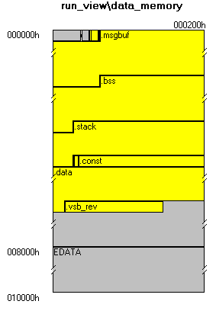
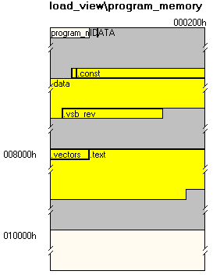 | 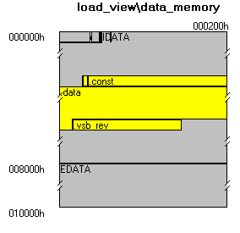

******************************************************************************
TMS320C54x COFF vLinker Version 2.10
******************************************************************************
>> Linked Tue Jun 19 02:35:06 2007

OUTPUT FILE NAME: <\\nibbles\dsp-sw\GE2P\Debug\ge2p.out>
ENTRY POINT SYMBOL: "_c_int00" address: 0000f686

MEMORY CONFIGURATION

name origin length used attr fill
---------------------- -------- --------- -------- ---- --------
CPUREGS 00000000 000000000 00000000 RWIX 0001
USERREGS 00000060 000000000 00000000 IX 0001
BIOSREGS 0000007c 000000000 00000000 X 0001
IDATA 00000080 000000000 00000000 0000
IDATA 00000080 000000000 00000000 0001
EDATA 00008000 000000000 00000000 0001
EPROG 00008000 000000000 00000000 0000

SECTION ALLOCATION MAP

output attributes/
section page origin length input sections
-------- ---- ---------- ---------- ----------------
___page_info__
* 0 00000000 00000004 DSECT
00000000 00000004 --PAGE INFORMATION--

___section_info__
* 0 00000000 00000004 DSECT
00000000 00000004 --SECTION INFORMATION--

.vectors 0 00008000 00000080
00008000 00000080 vectors.obj (.vectors)

.text 0 00008080 0000773f
00008080 00002070 g729ab.o54 (.text:enc)
0000a0f0 00000c9f B_Channel.obj (.text)
0000ad8f 00000b1d ecmr.o54 (.text)
0000b8ac 000007de g729ab.o54 (.text:dec)
0000c08a 0000074b Main.obj (.text)
0000c7d5 000006f9 ELU28_Master.obj (.text)
0000cece 00000688 ELU28_Slave.obj (.text)
0000d556 000005e6 G726.o54 (.text)
0000db3c 000004fe fmtd.o54 (.text)
0000e03a 000004e7 IrqHandlers.obj (.text)
0000e521 0000049a DTS.obj (.text)
0000e9bb 00000310 ELU28.obj (.text)
0000eccb 000001f3 MsgBuf.obj (.text)
0000eebe 000001d4 stdio.obj (.text)
0000f092 0000019f g711.obj (.text)
0000f231 0000011d nfe.o54 (.text)
0000f34e 000000f5 DASL.obj (.text)
0000f443 000000e6 g729ab.o54 (.text:ini)
0000f529 000000a5 rts.lib : ldiv.obj (.text)
0000f5ce 00000064 Utility.obj (.text)
0000f632 00000054 rts.lib : exit.obj (.text)
0000f686 0000004a : boot.obj (.text)
0000f6d0 0000003b G726.o54 (.text:init)
0000f70b 00000037 rts.lib : idiv.obj (.text)
0000f742 0000002d comm.lib : tsqrt.o54 (.text)
0000f76f 00000019 : lin2db.o54 (.text)
0000f788 00000014 rts.lib : lmpy.obj (.text)
0000f79c 00000011 : lsrs.obj (.text)
0000f7ad 0000000b comm.lib : db2lin.o54 (.text)
0000f7b8 00000007 rts.lib : _lock.obj (.text)

.sysregs 1 0000007c 00000000 UNINITIALIZED

.b1mem 1 00000080 0000001a UNINITIALIZED
00000080 0000001a B_Channel.obj (.b1mem)

.sysparm 1 0000009a 00000004
0000009a 00000004 Main.obj (.sysparm)

.msgbuf 1 0000009e 00001000 UNINITIALIZED
0000009e 00001000 stdio.obj (.msgbuf)

.bss 1 0000109e 000043a6 UNINITIALIZED
0000109e 00004322 Main.obj (.bss)
000053c0 00000009 IrqHandlers.obj (.bss)
000053c9 00000055 B_Channel.obj (.bss)
0000541e 00000023 rts.lib : exit.obj (.bss)
00005441 00000002 : _lock.obj (.bss)
00005443 00000001 Utility.obj (.bss)

.MEM$obj 1 00005444 00000000 UNINITIALIZED

.cio 1 00005444 00000000 UNINITIALIZED

.far 1 00005444 00000000 UNINITIALIZED

.sysheap 1 00005444 00000000 UNINITIALIZED

.stack 1 00005444 00000600 UNINITIALIZED
00005444 00000000 rts.lib : boot.obj (.stack)

.pinit 1 00005a44 00000004
00005a44 00000001 stdio.obj (.pinit)
00005a45 00000001 Main.obj (.pinit)
00005a46 00000002 --HOLE-- [fill = 0000]

.cinit 1 00005a44 00000076 COPY SECTION
00005a44 00000050 Main.obj (.cinit)
00005a94 00000013 IrqHandlers.obj (.cinit)
00005aa7 00000009 rts.lib : exit.obj (.cinit)
00005ab0 00000006 : _lock.obj (.cinit)
00005ab6 00000003 Utility.obj (.cinit)
00005ab9 00000001 --HOLE-- [fill = 0000]

.switch 1 00005a48 00000010
00005a48 00000010 DTS.obj (.switch)

.sysinit 1 00005a58 00000000 UNINITIALIZED

.const 1 00005a58 000001a6
00005a58 00000153 B_Channel.obj (.const)
00005bab 0000001d Utility.obj (.const)
00005bc8 00000019 DASL.obj (.const)
00005be1 00000011 stdio.obj (.const)
00005bf2 00000004 ELU28_Slave.obj (.const)
00005bf6 00000004 ELU28_Master.obj (.const)
00005bfa 00000004 ELU28.obj (.const)

.data 1 00005bfe 00000e2a
00005bfe 00000c67 g729ab.o54 (.data)
00006865 000000e2 G726.o54 (.data)
00006947 00000051 comm.lib : db2lin.o54 (.data)
00006998 00000031 : tsqrt.o54 (.data)
000069c9 0000002f nfe.o54 (.data)
000069f8 00000023 ecmr.o54 (.data)
00006a1b 0000000d fmtd.o54 (.data)

.d2_rev 1 00006a28 0000002c DSECT
00006a28 0000002c ecmr.o54 (.d2_rev)

.vsb_rev 1 00006a28 0000014a DSECT
00006a28 0000006e g729ab.o54 (.vsb_rev)
00006a96 0000005c G726.o54 (.vsb_rev)
00006af2 0000002b fmtd.o54 (.vsb_rev)
00006b1d 0000002b comm.lib : comm_ver.o54 (.vsb_rev)
00006b48 0000002a nfe.o54 (.vsb_rev)

GLOBAL SYMBOLS: SORTED ALPHABETICALLY BY Name

address name
-------- ----
0000109e $bss
0000109e .bss
00005bfe .data
00008080 .text
0000f683 C$$EXIT
00006b1d COMM_VER
0000f70b I$$DIV
0000f727 I$$MOD
0000f529 L$$DIVS
0000f579 L$$DIVU
0000f551 L$$MODS
0000f595 L$$MODU
0000f788 L$$MPY
0000f79c L$$SRS
00001c5a _B0
000037e6 _B1
00000029 _BSCR
00000058 _CLKMD
0000aa5a _ChangeParameters__9B_ChannelFPUci
00003510 _D0
0000509c _D1
0000e503 _DMA4_handler
0000e512 _DMA5_handler
00000021 _DRR10
00000041 _DRR11
00000031 _DRR12
00000020 _DRR20
00000040 _DRR21
00000030 _DRR22
00000023 _DXR10
00000043 _DXR11
00000033 _DXR12
00000022 _DXR20
00000042 _DXR21
00000032 _DXR22
0000a259 _DataReady_EH__9B_ChannelFv
0000ae41 _ECMR_init
0000af98 _ECMR_run
0000dbd7 _FMTD_detect
0000e001 _FMTD_fullDuplexDetect
0000db3c _FMTD_init
0000f1c6 _G711_decode_aLaw__FPiPCUsi
0000f20a _G711_decode_uLaw__FPiPCUsi
0000f1a5 _G711_encode_aLaw__FPUsPCii
0000f1e5 _G711_encode_uLaw__FPUsPCii
0000f18a _G711_gen1kHz_aLaw__FPUsi
0000f175 _G711_gen4kHz_aLaw__FPUsi
0000d61b _G726_decode
0000d556 _G726_encode
0000f6d0 _G726_init
0000b8ac _G729AB_decode
00008080 _G729AB_encode
0000f443 _G729AB_init
0000ee30 _GetUnpack__6MSGBUFFRiPUci
0000e07b _HINT_handler
0000002c _HPIC
00000001 _IFR
00005378 _ILC_State
00000000 _IMR
0000e2a9 _INT0_handler
0000e3c7 _INT1_handler
0000e4e5 _INT2_handler
0000e4f4 _INT3_handler
00008000 _ISR_table__Fv
0000a9c1 _InitEncoder__9B_ChannelFi
0000c08a _Init_DASLs__Fv
0000f5ce _Init_DSP__Fv
0000f5e2 _Init_PLL__FUi
0000eebe _Init_STDIO__Fv
0000f5fd _Init_Timer__Fv
0000ec80 _Initialize__15ELU28_D_ChannelFv
0000f34e _Initialize__4DASLFQ2_4DASL8TDM_Sync
0000a1a9 _Initialize__9B_ChannelFP15ELU28_D_Channelb
0000f3a7 _IsStatusChanged__4DASLSFv
0000a922 _LEC_Init__9B_ChannelFb
0000cca9 _Master_DASL_EH__15ELU28_D_ChannelFv
0000c7d5 _Master_RcvBuf_EH__15ELU28_D_ChannelFv
0000caa5 _Master_Timed_EH__15ELU28_D_ChannelFv
0000f231 _NFE_init
0000f2a7 _NFE_run
00005443 _PLLMULT
0000001d _PMST
00000025 _PRD
0000e854 _ParsePDU_FromDTS__15ELU28_D_ChannelFPUci
0000e521 _ParsePDU_FromPBX__15ELU28_D_ChannelFPUci
0000e9bb _PutPDU__15D_TransmitQueueFPUci
0000ed61 _PutPack__6MSGBUFF7MSGTYPEPCUci
0000a0f0 _Put__14B_JitterBufferFUlPUci
0000ece5 _Put__6MSGBUFF7MSGTYPEPCUsi
0000ee07 _Put__6MSGBUFFPCci
0000e08a _RINT0_handler
0000e1c3 _RINT1_handler
0000e28b _RINT2_handler
00001c58 _Repeater_Mode
00000038 _SPSA0
00000048 _SPSA1
00000034 _SPSA2
00000039 _SPSD0
00000049 _SPSD1
00000035 _SPSD2
0000002b _SWCR
00000028 _SWWSR
0000d32f _Slave_DASL_EH__15ELU28_D_ChannelFv
0000cece _Slave_RcvBuf_EH__15ELU28_D_ChannelFv
0000d1e1 _Slave_Timed_EH__15ELU28_D_ChannelFv
0000a8b8 _StartTransmission__9B_ChannelFv
0000a919 _StopTransmission__9B_ChannelFv
00005372 _SysT1
00000026 _TCR
00000024 _TIM
000053c8 _TINT_arrived
0000e03a _TINT_handler
0000f3af _Update__4DASLFv
0000e1b4 _XINT0_handler
0000e27c _XINT1_handler
0000e29a _XINT2_handler
0000001e _XPC
00000600 __STACK_SIZE
0000109e ___bss__
ffffffff ___cinit__
0000eb78 ___ct__15ELU28_D_ChannelFiP9B_Channel
0000eccb ___ct__6MSGBUFFv
00005bfe ___data__
00006a28 ___edata__
00005444 ___end__
0000f7bf ___etext__
0000f625 ___nw__FUi
00005a44 ___pinit__
0000c643 ___sti__main_cpp_params
0000f087 ___sti__stdio_cpp_inBuf
00008080 ___text__
0000543f __cleanup_ptr
00005440 __dtors_ptr
00000001 __lflags
00005441 __lock
0000f7b8 __nop
0000f7b9 __register_lock
0000f7bc __register_unlock
00005442 __unlock
0000f0ca _aLaw_to_s13__Fi
0000f683 _abort
0000f661 _atexit
0000f686 _c_int00
000053c4 _counter_B0_irq
000053c6 _counter_B1_irq
000053c0 _counter_D0_irq
000053c2 _counter_D1_irq
0000f632 _exit
0000537c _idle
0000009e _inBuf
0000f76f _lin2db
0000c0d9 _main
0000537a _maxIdle
0000089e _outBuf
0000009a _params
0000f092 _s13_to_aLaw__Fi
0000f0f9 _s14_to_uLaw__Fi
00001c57 _temp_msg
0000eec9 _tracef__FPCce
0000f742 _tsqrt
0000f144 _uLaw_to_s14__Fi
00005376 _uptime
00001c56 _vpoStack_ptr
ffffffff cinit
0000f7ad dB2lin
00006a28 edata
00005444 end
0000f7bf etext
00005a44 pinit

GLOBAL SYMBOLS: SORTED BY Symbol Address

address name
-------- ----
00000000 _IMR
00000001 _IFR
00000001 __lflags
0000001d _PMST
0000001e _XPC
00000020 _DRR20
00000021 _DRR10
00000022 _DXR20
00000023 _DXR10
00000024 _TIM
00000025 _PRD
00000026 _TCR
00000028 _SWWSR
00000029 _BSCR
0000002b _SWCR
0000002c _HPIC
00000030 _DRR22
00000031 _DRR12
00000032 _DXR22
00000033 _DXR12
00000034 _SPSA2
00000035 _SPSD2
00000038 _SPSA0
00000039 _SPSD0
00000040 _DRR21
00000041 _DRR11
00000042 _DXR21
00000043 _DXR11
00000048 _SPSA1
00000049 _SPSD1
00000058 _CLKMD
0000009a _params
0000009e _inBuf
00000600 __STACK_SIZE
0000089e _outBuf
0000109e $bss
0000109e .bss
0000109e ___bss__
00001c56 _vpoStack_ptr
00001c57 _temp_msg
00001c58 _Repeater_Mode
00001c5a _B0
00003510 _D0
000037e6 _B1
0000509c _D1
00005372 _SysT1
00005376 _uptime
00005378 _ILC_State
0000537a _maxIdle
0000537c _idle
000053c0 _counter_D0_irq
000053c2 _counter_D1_irq
000053c4 _counter_B0_irq
000053c6 _counter_B1_irq
000053c8 _TINT_arrived
0000543f __cleanup_ptr
00005440 __dtors_ptr
00005441 __lock
00005442 __unlock
00005443 _PLLMULT
00005444 ___end__
00005444 end
00005a44 ___pinit__
00005a44 pinit
00005bfe .data
00005bfe ___data__
00006a28 ___edata__
00006a28 edata
00006b1d COMM_VER
00008000 _ISR_table__Fv
00008080 .text
00008080 _G729AB_encode
00008080 ___text__
0000a0f0 _Put__14B_JitterBufferFUlPUci
0000a1a9 _Initialize__9B_ChannelFP15ELU28_D_Channelb
0000a259 _DataReady_EH__9B_ChannelFv
0000a8b8 _StartTransmission__9B_ChannelFv
0000a919 _StopTransmission__9B_ChannelFv
0000a922 _LEC_Init__9B_ChannelFb
0000a9c1 _InitEncoder__9B_ChannelFi
0000aa5a _ChangeParameters__9B_ChannelFPUci
0000ae41 _ECMR_init
0000af98 _ECMR_run
0000b8ac _G729AB_decode
0000c08a _Init_DASLs__Fv
0000c0d9 _main
0000c643 ___sti__main_cpp_params
0000c7d5 _Master_RcvBuf_EH__15ELU28_D_ChannelFv
0000caa5 _Master_Timed_EH__15ELU28_D_ChannelFv
0000cca9 _Master_DASL_EH__15ELU28_D_ChannelFv
0000cece _Slave_RcvBuf_EH__15ELU28_D_ChannelFv
0000d1e1 _Slave_Timed_EH__15ELU28_D_ChannelFv
0000d32f _Slave_DASL_EH__15ELU28_D_ChannelFv
0000d556 _G726_encode
0000d61b _G726_decode
0000db3c _FMTD_init
0000dbd7 _FMTD_detect
0000e001 _FMTD_fullDuplexDetect
0000e03a _TINT_handler
0000e07b _HINT_handler
0000e08a _RINT0_handler
0000e1b4 _XINT0_handler
0000e1c3 _RINT1_handler
0000e27c _XINT1_handler
0000e28b _RINT2_handler
0000e29a _XINT2_handler
0000e2a9 _INT0_handler
0000e3c7 _INT1_handler
0000e4e5 _INT2_handler
0000e4f4 _INT3_handler
0000e503 _DMA4_handler
0000e512 _DMA5_handler
0000e521 _ParsePDU_FromPBX__15ELU28_D_ChannelFPUci
0000e854 _ParsePDU_FromDTS__15ELU28_D_ChannelFPUci
0000e9bb _PutPDU__15D_TransmitQueueFPUci
0000eb78 ___ct__15ELU28_D_ChannelFiP9B_Channel
0000ec80 _Initialize__15ELU28_D_ChannelFv
0000eccb ___ct__6MSGBUFFv
0000ece5 _Put__6MSGBUFF7MSGTYPEPCUsi
0000ed61 _PutPack__6MSGBUFF7MSGTYPEPCUci
0000ee07 _Put__6MSGBUFFPCci
0000ee30 _GetUnpack__6MSGBUFFRiPUci
0000eebe _Init_STDIO__Fv
0000eec9 _tracef__FPCce
0000f087 ___sti__stdio_cpp_inBuf
0000f092 _s13_to_aLaw__Fi
0000f0ca _aLaw_to_s13__Fi
0000f0f9 _s14_to_uLaw__Fi
0000f144 _uLaw_to_s14__Fi
0000f175 _G711_gen4kHz_aLaw__FPUsi
0000f18a _G711_gen1kHz_aLaw__FPUsi
0000f1a5 _G711_encode_aLaw__FPUsPCii
0000f1c6 _G711_decode_aLaw__FPiPCUsi
0000f1e5 _G711_encode_uLaw__FPUsPCii
0000f20a _G711_decode_uLaw__FPiPCUsi
0000f231 _NFE_init
0000f2a7 _NFE_run
0000f34e _Initialize__4DASLFQ2_4DASL8TDM_Sync
0000f3a7 _IsStatusChanged__4DASLSFv
0000f3af _Update__4DASLFv
0000f443 _G729AB_init
0000f529 L$$DIVS
0000f551 L$$MODS
0000f579 L$$DIVU
0000f595 L$$MODU
0000f5ce _Init_DSP__Fv
0000f5e2 _Init_PLL__FUi
0000f5fd _Init_Timer__Fv
0000f625 ___nw__FUi
0000f632 _exit
0000f661 _atexit
0000f683 C$$EXIT
0000f683 _abort
0000f686 _c_int00
0000f6d0 _G726_init
0000f70b I$$DIV
0000f727 I$$MOD
0000f742 _tsqrt
0000f76f _lin2db
0000f788 L$$MPY
0000f79c L$$SRS
0000f7ad dB2lin
0000f7b8 __nop
0000f7b9 __register_lock
0000f7bc __register_unlock
0000f7bf ___etext__
0000f7bf etext
ffffffff ___cinit__
ffffffff cinit

[169 symbols]

GE2P.str
Strategy Used by the GE2P recipe. Created on June 05, 2005.

CHANGE auto initialization OF c54x TO RAM_auto_init
CHANGE vectors OF vectors.obj\.vectors TO TRUE
CHANGE entry OF rts.lib\boot.obj\.text\_c_int00 TO TRUE
REQUIRE everything but unreferenced conditionally linked sections BE IN run_view
CHANGE stack size OF c54x TO 0600h
CHANGE heap size OF c54x TO 00h
NEW child output file OF Output Files WITH full_path=.\Debug\ge2p.out HOLDING map c54x
CHANGE make map file OF Output Files\ge2p.out TO TRUE
CHANGE map file name OF Output Files\ge2p.out TO ".\Debug\ge2p.map"
NEW child output section OF run_view\program_memory\EPROG WITH name=.vectors, data_kind=hole
CHANGE dont inherit fill OF run_view\program_memory\EPROG\.vectors TO TRUE
CHANGE force load placement OF run_view\program_memory\EPROG\.vectors TO TRUE
CHANGE alloc_kind OF run_view\program_memory\EPROG TO legacy_region
NEW child output section OF run_view\program_memory\EPROG WITH name=.text, data_kind=hole
CHANGE dont inherit fill OF run_view\program_memory\EPROG\.text TO TRUE
CHANGE force load placement OF run_view\program_memory\EPROG\.text TO TRUE
NEW child output section OF run_view\data_memory\BIOSREGS WITH name=.sysregs, data_kind=hole
CHANGE dont inherit fill OF run_view\data_memory\BIOSREGS\.sysregs TO TRUE
CHANGE force load placement OF run_view\data_memory\BIOSREGS\.sysregs TO TRUE
NEW child output section OF run_view\data_memory\IDATA WITH name=.sysparm, data_kind=hole
CHANGE dont inherit fill OF run_view\data_memory\IDATA\.sysparm TO TRUE
CHANGE force load placement OF run_view\data_memory\IDATA\.sysparm TO TRUE
CHANGE alloc_kind OF run_view\data_memory\IDATA TO legacy_region
NEW child output section OF run_view\data_memory\IDATA WITH name=.msgbuf, data_kind=hole
CHANGE dont inherit fill OF run_view\data_memory\IDATA\.msgbuf TO TRUE
CHANGE force load placement OF run_view\data_memory\IDATA\.msgbuf TO TRUE
NEW child output section OF run_view\data_memory\IDATA WITH name=.bss, data_kind=hole
CHANGE dont inherit fill OF run_view\data_memory\IDATA\.bss TO TRUE
CHANGE force load placement OF run_view\data_memory\IDATA\.bss TO TRUE
NEW child output section OF run_view\data_memory\IDATA WITH name=.MEM$obj, data_kind=hole
CHANGE dont inherit fill OF run_view\data_memory\IDATA\.MEM$obj TO TRUE
CHANGE force load placement OF run_view\data_memory\IDATA\.MEM$obj TO TRUE
NEW child output section OF run_view\data_memory\IDATA WITH name=.far, data_kind=hole
CHANGE dont inherit fill OF run_view\data_memory\IDATA\.far TO TRUE
CHANGE force load placement OF run_view\data_memory\IDATA\.far TO TRUE
NEW child output section OF run_view\data_memory\IDATA WITH name=.sysheap, data_kind=hole
CHANGE dont inherit fill OF run_view\data_memory\IDATA\.sysheap TO TRUE
CHANGE force load placement OF run_view\data_memory\IDATA\.sysheap TO TRUE
NEW child output section OF run_view\data_memory\IDATA WITH name=.cio, data_kind=hole
CHANGE dont inherit fill OF run_view\data_memory\IDATA\.cio TO TRUE
CHANGE force load placement OF run_view\data_memory\IDATA\.cio TO TRUE
MOVE children of run_view\Not Yet Placed WITH kind=output section, base name=.sysmem TO run_view\data_memory\IDATA
ADD run_view\Not Yet Placed\.stack TO run_view\data_memory\IDATA
CHANGE dont inherit fill OF run_view\data_memory\IDATA\.stack TO TRUE
MOVE .cinit FROM run_view\Need Not Place TO run_view\data_memory\IDATA
CHANGE dont inherit fill OF run_view\data_memory\IDATA\.cinit TO TRUE
ADD run_view\Not Yet Placed\.pinit TO run_view\data_memory\IDATA
CHANGE dont inherit fill OF run_view\data_memory\IDATA\.pinit TO TRUE
NEW child output section OF run_view\data_memory\IDATA WITH name=.switch, data_kind=hole
CHANGE dont inherit fill OF run_view\data_memory\IDATA\.switch TO TRUE
CHANGE force load placement OF run_view\data_memory\IDATA\.switch TO TRUE
NEW child output section OF run_view\data_memory\IDATA WITH name=.sysinit, data_kind=hole
CHANGE dont inherit fill OF run_view\data_memory\IDATA\.sysinit TO TRUE
CHANGE force load placement OF run_view\data_memory\IDATA\.sysinit TO TRUE
NEW child output section OF run_view\data_memory\IDATA WITH name=.const, data_kind=hole
CHANGE dont inherit fill OF run_view\data_memory\IDATA\.const TO TRUE
CHANGE force load placement OF run_view\data_memory\IDATA\.const TO TRUE
NEW child output section OF run_view\data_memory\IDATA WITH name=.data, data_kind=hole
CHANGE dont inherit fill OF run_view\data_memory\IDATA\.data TO TRUE
CHANGE force load placement OF run_view\data_memory\IDATA\.data TO TRUE
NEW child output section OF run_view\data_memory\IDATA WITH name=.d2_rev, data_kind=hole, specl_kind=dsect
CHANGE dont inherit fill OF run_view\data_memory\IDATA\.d2_rev TO TRUE
CHANGE force load placement OF run_view\data_memory\IDATA\.d2_rev TO TRUE
NEW child output section OF run_view\data_memory\IDATA WITH name=.vsb_rev, data_kind=hole, specl_kind=dsect
CHANGE dont inherit fill OF run_view\data_memory\IDATA\.vsb_rev TO TRUE
CHANGE force load placement OF run_view\data_memory\IDATA\.vsb_rev TO TRUE
ADD children of run_view\Not Yet Placed WITH kind=any section, base name=.vectors TO run_view\program_memory\EPROG\.vectors
CHANGE force load placement OF run_view\program_memory\EPROG\.vectors TO FALSE
ADD children of run_view\Not Yet Placed WITH kind=any section, base name=.text TO run_view\program_memory\EPROG\.text
CHANGE force load placement OF run_view\program_memory\EPROG\.text TO FALSE
ADD children of run_view\Not Yet Placed WITH kind=any section, base name=.sysregs TO run_view\data_memory\BIOSREGS\.sysregs
CHANGE force load placement OF run_view\data_memory\BIOSREGS\.sysregs TO FALSE
ADD children of run_view\Not Yet Placed WITH kind=any section, base name=.sysparm TO run_view\data_memory\IDATA\.sysparm
CHANGE force load placement OF run_view\data_memory\IDATA\.sysparm TO FALSE
ADD children of run_view\Not Yet Placed WITH kind=any section, base name=.msgbuf TO run_view\data_memory\IDATA\.msgbuf
CHANGE force load placement OF run_view\data_memory\IDATA\.msgbuf TO FALSE
ADD children of run_view\Not Yet Placed WITH kind=any section, base name=.bss TO run_view\data_memory\IDATA\.bss
CHANGE force load placement OF run_view\data_memory\IDATA\.bss TO FALSE
ADD children of run_view\Not Yet Placed WITH kind=any section, base name=.MEM$obj TO run_view\data_memory\IDATA\.MEM$obj
CHANGE force load placement OF run_view\data_memory\IDATA\.MEM$obj TO FALSE
ADD children of run_view\Not Yet Placed WITH kind=any section, base name=.far TO run_view\data_memory\IDATA\.far
CHANGE force load placement OF run_view\data_memory\IDATA\.far TO FALSE
ADD children of run_view\Not Yet Placed WITH kind=any section, base name=.sysheap TO run_view\data_memory\IDATA\.sysheap
CHANGE force load placement OF run_view\data_memory\IDATA\.sysheap TO FALSE
ADD children of run_view\Not Yet Placed WITH kind=any section, base name=.cio TO run_view\data_memory\IDATA\.cio
CHANGE force load placement OF run_view\data_memory\IDATA\.cio TO FALSE
ADD children of run_view\Not Yet Placed WITH kind=any section, base name=.switch TO run_view\data_memory\IDATA\.switch
CHANGE force load placement OF run_view\data_memory\IDATA\.switch TO FALSE
ADD children of run_view\Not Yet Placed WITH kind=any section, base name=.sysinit TO run_view\data_memory\IDATA\.sysinit
CHANGE force load placement OF run_view\data_memory\IDATA\.sysinit TO FALSE
ADD children of run_view\Not Yet Placed WITH kind=any section, base name=.const TO run_view\data_memory\IDATA\.const
CHANGE force load placement OF run_view\data_memory\IDATA\.const TO FALSE
ADD children of run_view\Not Yet Placed WITH kind=any section, base name=.data TO run_view\data_memory\IDATA\.data
CHANGE force load placement OF run_view\data_memory\IDATA\.data TO FALSE
ADD children of run_view\Not Yet Placed WITH kind=any section, base name=.d2_rev TO run_view\data_memory\IDATA\.d2_rev
CHANGE force load placement OF run_view\data_memory\IDATA\.d2_rev TO FALSE
ADD children of run_view\Not Yet Placed WITH kind=any section, base name=.vsb_rev TO run_view\data_memory\IDATA\.vsb_rev
CHANGE force load placement OF run_view\data_memory\IDATA\.vsb_rev TO FALSE
CHANGE fill_holes OF run_view\program_memory\EPROG\.vectors TO TRUE
CHANGE fill_holes OF run_view\program_memory\EPROG\.text TO TRUE
CHANGE fill_holes OF run_view\data_memory\IDATA\.sysparm TO TRUE
CHANGE fill_holes OF run_view\data_memory\IDATA\.switch TO TRUE
CHANGE fill_holes OF run_view\data_memory\IDATA\.const TO TRUE
CHANGE fill_holes OF run_view\data_memory\IDATA\.data TO TRUE
CHANGE fill_holes OF run_view\data_memory\IDATA\.d2_rev TO TRUE
CHANGE fill_holes OF run_view\data_memory\IDATA\.vsb_rev TO TRUE
CHANGE alloc_kind OF run_view\data_memory\IDATA TO struct
CHANGE alloc_kind OF run_view\program_memory\EPROG TO struct
NEW child output section OF run_view\data_memory\IDATA WITH name=.b1mem, data_kind=hole
ADD B_Channel.obj\.b1mem TO run_view\data_memory\IDATA\.b1mem
ALIGN run address of run_view\data_memory\IDATA\.b1mem TO an address with 4 0's in the LSBs
ALIGN load address of run_view\data_memory\IDATA\.b1mem TO an address with 4 0's in the LSBs
REORDER .b1mem WITHIN run_view\data_memory\IDATA BEFORE run_view\data_memory\IDATA\.vsb_rev
REORDER .b1mem WITHIN run_view\data_memory\IDATA BEFORE run_view\data_memory\IDATA\.d2_rev
REORDER .b1mem WITHIN run_view\data_memory\IDATA BEFORE run_view\data_memory\IDATA\.data
REORDER .b1mem WITHIN run_view\data_memory\IDATA BEFORE run_view\data_memory\IDATA\.const
REORDER .b1mem WITHIN run_view\data_memory\IDATA BEFORE run_view\data_memory\IDATA\.sysinit
REORDER .b1mem WITHIN run_view\data_memory\IDATA BEFORE run_view\data_memory\IDATA\.switch
REORDER .b1mem WITHIN run_view\data_memory\IDATA BEFORE run_view\data_memory\IDATA\.pinit
REORDER .b1mem WITHIN run_view\data_memory\IDATA BEFORE run_view\data_memory\IDATA\.cinit
REORDER .b1mem WITHIN run_view\data_memory\IDATA BEFORE run_view\data_memory\IDATA\.stack
REORDER .b1mem WITHIN run_view\data_memory\IDATA BEFORE run_view\data_memory\IDATA\.cio
REORDER .b1mem WITHIN run_view\data_memory\IDATA BEFORE run_view\data_memory\IDATA\.sysheap
REORDER .b1mem WITHIN run_view\data_memory\IDATA BEFORE run_view\data_memory\IDATA\.far
REORDER .b1mem WITHIN run_view\data_memory\IDATA BEFORE run_view\data_memory\IDATA\.MEM$obj
REORDER .b1mem WITHIN run_view\data_memory\IDATA BEFORE run_view\data_memory\IDATA\.bss
REORDER .b1mem WITHIN run_view\data_memory\IDATA BEFORE run_view\data_memory\IDATA\.msgbuf
REORDER .b1mem WITHIN run_view\data_memory\IDATA BEFORE run_view\data_memory\IDATA\.sysparm
CHANGE strip debug OF Output Files\ge2p.out TO TRUE
END GE2P

